Project Planning Phase

**Project Planning Template (Product Backlog, Sprint Planning, Stories, Story points)**

|  |  |
| --- | --- |
| Date | 2 July 2025 |
| Team ID | LTVIP2025TMID50858 |
| Project Name | ToyCraft Tales: Tableau's Vision into Toy Manufacturer Data |
| Maximum Marks | 5 Marks |

Product Backlog, Sprint Schedule, and Estimation (4 Marks)

|  |  |  |  |  |  |  |
| --- | --- | --- | --- | --- | --- | --- |
| **print** | **Functional**  **Requirement (Epic)** | **User Story Number** | **User Story / Task** | **Story Points** | **Priority** | **Team Members** |
| Sprint- 1 | Dashboard widgets | USN-1 | As a user, I want to view Product sales by category on a dashboard to identify bestaligns. | 3 | High | Bhavana |
| Sprint- 1 | Dashboard widgets | USN-2 | As a user, I want to compare Product sales across different regions on a dashboard for geographic insights. | 2 | High | Poornima |
| Sprint- 1 | Filter Options | USN-4 | As a user, I want to filter products to show only the top-rated items based on users. | 3 | Medium | Bhavana |
| Sprint- 2 | Filter Options | USN-5 | As a user, I want to filter products by price range on the dashboard to find item within my budget. | 3 | High | Bhavana |
| Sprint- 2 | Filter Options | USN-6 | As a user, I want to filter products by availability to ensure items are in stock when I view them. | 2 | Medium | Poornima |
| Sprint- 2 | Filter Options | USN-7 | As a user, I want to filter products by category to narrow down choices for easier browsing. | 1 | Low | bhavana |
| Sprint- 3 | Map Integration | USN-8 | As a user, I want to view store locations on a map for better navigation. | 4 | Low | Poornima |

|  |  |  |  |  |  |  |
| --- | --- | --- | --- | --- | --- | --- |
| Sprint- 3 | Dashboard Expert | USN-9 | As a user, I want to export dashboard data to a spreadsheet for analysis and reporting. | 4 | High | Bhavana |

Project Tracker, Velocity & Burndown Chart: (4 Marks)

|  |  |  |  |  |  |  |
| --- | --- | --- | --- | --- | --- | --- |
| **Sprint** | **Total Story Points** | **Duration** | **Sprint Start Date** | **Sprint End Date (Planned)** | **Story Points Completed (as on Planned End Date)** | **Sprint Release Date (Actual)** |
| **Sprint- 1** | 20 | 6 days | 24 Jun 2025 | 27 Jun 2025 | 20 | 27 Jun 2025 |
| **Sprint- 2** | 20 | 6 days | 01 Jul 2025 | 06 Jul 2025 | — | — |
| **Sprint- 3** | 20 | 6 days | 08 Jul 2025 | 13 Jul 2025 | — | — |
| **Sprint- 4** | 20 | 6 days | 15 Jul 2025 | 20 Jul 2025 | — | — |

Velocity:

Imagine we have a 10-day sprint duration, and the velocity of the team is 20 (points per sprint). Let’s calculate the team’s average velocity (AV) per iteration unit (story points per day)



Burndown Chart:

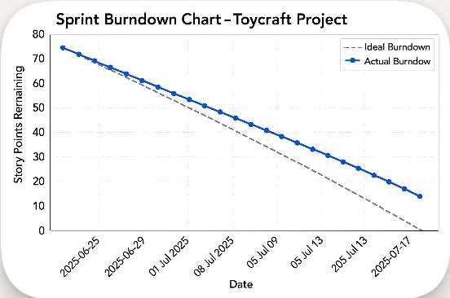

<https://www.visual-paradigm.com/scrum/scrum-burndown-chart/>

<https://www.atlassian.com/agile/tutorials/burndown-charts>

Reference:

<https://www.atlassian.com/agile/project-management>

<https://www.atlassian.com/agile/tutorials/how-to-do-scrum-with-jira-software> <https://www.atlassian.com/agile/tutorials/epics>

<https://www.atlassian.com/agile/tutorials/sprints> <https://www.atlassian.com/agile/project-management/estimation> <https://www.atlassian.com/agile/tutorials/burndown-charts>